# **Climate Change**

**The Eurasian Group** recognizes the global challenge of anthropogenic climate change and is working actively contributing to prevention of these risks. We realize that, like Kazakhstan, our group has historically relied on coal fuel in its energy mix, making climate risks an important factor in our strategic decisions.

## **Climate Policy**

**We believe in a sustainable future!**

ERG continues active development, focusing on the best global practices and technologies, to not maintain and improve the climate situation on the planet. The contribution of each of us is important to create an environmentally sustainable future. In 2023, ERG in Kazakhstan approved the Policy for Managing the Impact and Adaptation of the Group to Climate Change.

Basic principles of policy:

1. Increase resilience to climate change
2. Reduce the carbon footprint throughout the life cycle of our products
3. Introduce climate change aspects into strategy and decision-making process
4. Accelerate the transition to a low-GHG economy through stakeholder collaboration and partnerships development
5. Increase transparency of climate reporting

## **Decarbonization Strategy**

In 2024, we approved and published a Decarbonisation Strategy, which includes a number of initiatives aimed at reducing emissions and supporting sustainable development.

### Strategy Theses

1. **Ambitious climate goals**: Our main scenario assumes the preservation of ambitious climate policies in the world and the development of carbon regulation in Kazakhstan. We aim to reduce the carbon footprint of ferrochrome, aluminum and iron ore pellets by 30% by 2035, and by 2050 we strive to achieve a net-zero state for greenhouse gas emissions.
2. **Investments in technologies**: We are confident that the development of technologies will result in decreased capital expenditures (CAPEX) in decarbonization projects, which will allow them to be implemented at our industrial facilities. More than 100 decarbonization projects are in the Group's portfolio at various stages of development, and a significant share of our investments is aimed at reducing specific carbon intensity.
3. **Integration of climate aspects**: Climate aspects are integrated into the ERG Kazakhstan management system. We use the internal price of greenhouse gases to prevent investments in climate-negative projects, helping to ensure sustainable development.
4. **Fair energy transition**: We attach great importance to a fair energy transition for all stakeholders, including more than 60 thousand employees. Decisions on the rates of decarbonization are made with respect to regulatory policies and the growing demand for low-carbon products.

**Greenhouse Gas Emissions of ERG**

In 2023, **Eurasian Resources Group (ERG)** emissions amounted to **29.2 million tons of CO₂e**. These indicators cover both direct and indirect emissions across our divisions.

|  |  |  |  |
| --- | --- | --- | --- |
| GHG emissions (tCO2-e) | 2020 | 2021 | **2022** |
| Total | 29,594,438 | 30,142,643 | **29,877,178** |
| Direct | 115,602 | 125,590 | **53,508** |
| Indirect | 29,710,040 | 30,268,233 | **29,930,686** |

* **Direct emissions (Scope 1):** emissions that occur in the course of operations of our facilities.
* **Indirect emissions (Scope 2):** emissions associated with production processes and supply chains.

**Decarbonization and ERG initiatives in Kazakhstan**

We focus on the following key areas:

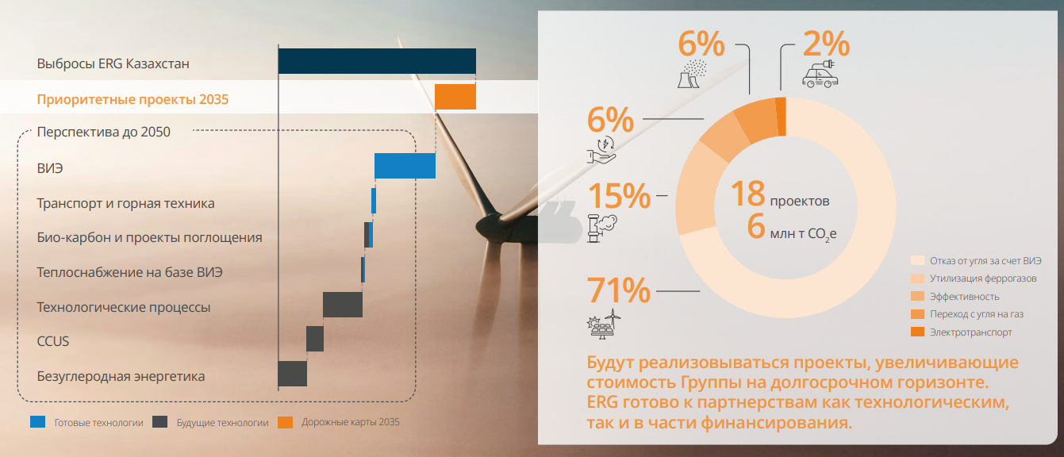

* **Renewable energy sources (RES**): Increase of the RES share in our energy mix.
* **Transport and mining equipment**: Upgrade of equipment to reduce emissions in these sectors.
* **Bio-carbon and sequestration projects**: Biomass utilization to increase carbon sequestration.
* **Heat supply based on RES**: Transition to renewable sources to ensure heat supply.
* **Technological processes**: Implementation of innovative solutions to reduce carbon footprint.
* **CCUS (Carbon Capture, Utilization and Storage)**: Development of carbon capture and storage projects.
* **Carbon-free energy**: Creating technologies for carbon-free energy production.

The Eurasian Group is open to partnerships in the field of technologies and financing, which will allow us to implement our plans more effectively. We are confident that joint efforts with other market players and scientific institutions will accelerate the achievement of the set results.